FakenewsAI: Identifying and Flagging Misinformation through Artificial Intelligence

|  |  |
| --- | --- |
| Abhishek Kumar(12013915)  Lovley Professional University | Aman Kumar(12020353)  Lovely Professional University |
| Rohan Raj(12017259)  Lovely Professional University |  |

***Abstract—*** **Misinformation has become a pervasive problem in today's society. With the rise of social media and the ease of sharing information, false or misleading information can spread rapidly and have a significant impact on public opinion and decision-making. The challenge of identifying and flagging misinformation has become increasingly difficult, as traditional methods of fact-checking and verification struggle to keep up with the scale and speed of information dissemination. In this research paper, we will explore the role of artificial intelligence (AI) in identifying and flagging misinformation, and the potential implications and future directions of this technology.**

***Keywords— Artificial Intelligence (AI), Machine Learning (ML), Misinformation, Detection, Fake news, FakenewsAI, Misleading, Efficacy Challenges, Ethical Considerations, Media Integrity, Societal Trust.***

# INTRODUCTION

Understanding the Problem of Misinformation can take many forms, from deliberate propaganda to unintentional errors and misunderstandings. The impact of misinformation can be significant, leading to public confusion, mistrust, and even harm. For example, during the COVID-19 pandemic, misinformation about the virus and its treatments has led to confusion and mistrust of public health measures, potentially contributing to the spread of the virus. Identifying and flagging misinformation is a complex challenge, as it requires not only identifying false or misleading information but also understanding the context and intent behind it. Traditional methods of fact checking and verification, such as manual fact-checking by journalists or experts, are time-consuming and often unable to keep up with the scale and speed of information dissemination. Therefore, there is a need for effective solutions to combat misinformation.

AI has the potential to automate the process of identifying and flagging misinformation, using techniques such as natural language processing, machine learning, and network analysis. Natural language processing can be used to analyze the language used in text or speech to identify patterns of misinformation, such as false claims or misleading language. Machine learning can be used to train algorithms to recognize patterns of misinformation based on previous examples, allowing for faster and more accurate identification. Network analysis can be used to identify the sources and spread of misinformation, allowing for targeted interventions. While AI has the potential to be a powerful tool in identifying and flagging misinformation, there are also limitations to its effectiveness. For example, AI may struggle to identify more subtle forms of misinformation, such as satire or irony, and may be susceptible to biases in its training data [1].

The potential impact of FakenewsAI, an AI-based system for identifying and flagging misinformation, is significant. It has the potential to improve the accuracy and speed of identifying and flagging misinformation, allowing for more effective interventions to combat it. However, there are also ethical and privacy concerns associated with the use of AI in identifying and flagging misinformation. For example, there may be concerns about the use of personal data to train AI algorithms or the potential for false positives or censorship [2]. Therefore, continued research and development are needed to improve the effectiveness and ethical implications of AI in detecting and combating misinformation. In conclusion, AI has the potential to be a valuable tool in the fight against misinformation, but it is important to approach its use with caution and to continue to develop and refine its capabilities [3].

## *Background & Motivation*

In recent years, the proliferation of misinformation has reached unprecedented levels, exacerbated by the widespread adoption of digital technologies and the rise of social media platforms. The democratization of content creation and dissemination has enabled the rapid spread of false or misleading information, posing significant challenges to information integrity and public trust. Misinformation, ranging from fabricated news articles to viral rumours and manipulated media, not only distorts public discourse but also undermines democratic processes and societal cohesion. Traditional methods of addressing misinformation, such as fact-checking and manual content moderation, have proven inadequate in the face of the sheer volume and velocity of deceptive content online [4]. Consequently, there is a pressing need for innovative solutions that can scale and adapt to the evolving landscape of digital misinformation. Against this backdrop, artificial intelligence (AI) has emerged as a promising tool for combating fake news and misinformation. By leveraging AI techniques such as natural language processing (NLP) and machine learning (ML), researchers and technologists have developed sophisticated algorithms capable of detecting and flagging deceptive content with a high degree of accuracy [5]. The intersection of AI and misinformation detection represents a burgeoning field of research and development, with implications for media integrity, societal trust, and the future of online discourse.

|  |  |  |  |
| --- | --- | --- | --- |
| Serial No. | Name of the author | Classifier Used | Accuracy |
| 1 |  |  |  |
| 2 |  |  |  |
| 3 |  |  |  |
| 4 |  |  |  |
| 5 |  |  |  |
| 6 |  |  |  |
| 7 |  |  |  |

## *Objectives*

This research paper aims to achieve several key objectives:

* Investigate the development and implementation of the 'FakenewsAI' system, focusing on its architecture, components, and operational mechanisms.
* Evaluate the efficacy of the 'FakenewsAI' system in detecting and flagging misinformation across various online platforms, employing performance metrics and real-world case studies.
* Identify and analyze the challenges associated with utilizing AI for combating fake news, including dataset biases, adversarial attacks, and issues related to explainability and transparency.
* Examine the ethical considerations inherent in deploying AI-driven misinformation detection systems, such as privacy concerns, algorithmic bias, and implications for freedom of speech.
* Provide insights into the potential impact of AI on media integrity and societal trust, exploring how these technologies can contribute to strengthening media literacy and fostering a more informed digital ecosystem.
* Offer recommendations for future research directions, policy interventions, and industry practices aimed at enhancing the effectiveness and ethical governance of AI-driven misinformation detection systems [6].
* By addressing these objectives, this research paper seeks to contribute to a deeper understanding of the opportunities and challenges associated with leveraging AI to combat fake news and promote a more trustworthy and resilient information environment.

# LITERATURE REVIEW

Before going into making the code for the following data it becomes very important to search about how research has been done in the field that we want to work upon. We have analysed quite a few papers that had done work upon fake news detection. Many types of model were trained which had many issues and had obtained many results which provided a lot of help in our project. The researchers have applied a lot of algorithms ranging from linear regression to deep learning algorithms. All the papers have first argued about how fake news has been troubling the world since a long time which has resulted in a lot of chaos including death in many cases. They have talked about the importance of classification of such news and how it becomes important to remove such propaganda to prevent treating misinformation as news. The research papers themselves have analysed several papers before proceeding on with their project to get an idea what goes wrong and how to add novelty to their project. Their papers discussed how the conversion of text to numeric values have been done where different methods of vectorization techniques have been used ranging from TF-IDF to Bag of Words(BOW). The process of data cleaning has been discussed where how data has been made into a proper dataset has been discussed and the use of NLP has been shown. Different type of algorithms has been discussed by their research papers like SVM, Random Forest to name a few. The use of deep learning algorithms like CNN have been shown and the final accuracies have been shown where importance to data classification has been given.

Now coming to the research papers, we can observe most of them have picked the dataset from LIAR dataset. Some other datasets are also included for example combined corpus by Junaed Younus Khan , Md. Tawkat Islam Khondaker , Anindya Iqbal and Sadia Afroz [7]. There has been a proper classification that has been done for the type of data they are getting for example visual based and user based. This has been discussed in detail by Syed Ishfaq Manzoor, Dr Jimmy Singla and Dr Nikita in their research paper [8]. For data cleaning different methods have been employed to remove all the unnecessary IP and the URL addresses. Whitespaces have been removed using stemming. TFI IDF has been used extensively for the vectorization techniques by most of the papers. The above two works have been done by Junaed Younus Khan.

BOW has been used in the research paper by Dr Singla. Another important point about data pointed out in the research papers was the issue of bias in data aligning with the models. Next all the 3 research papers have done the feature extraction where empath tool has been used for classifying the type of news as violent, misleading etc. Another important method used here is Lexical and Sentiment Feature extraction has been done where word count, word length has been used as lexical while positive and negative has been marked as lexical [9]. This works also has been done by the research paper made by Junaed Younus Khan. Next traditional models have been used such as SVM, Linear Regression, Decision Trees, Naïve Bayes and K-NN model by professors at Dhaka University. XG Boost and Random Forest were the new algorithms which were implemented by professors at LPU.

The paper made by Harsh Khatter argued about SVM being used to solve the problem and proposed a model combining of News Aggregator, Authenticator and Suggestion recommendation. Further deep learning algorithms have been implemented for the better learning of the data so that better accuracies are obtained. The paper by Dr Khatter implemented simple neural Networks for the same while the paper by Anindya Iqbal discussed about the CNN model and used several new deep learning algorithms like Hierarchical Attention Networks(HAN) and Convolutional HAN. Three types of LSTM were also used which includes LSTM,C-LSTM and Bi-LSTM. LSTM is basically Linguistic Inquiry and Word Count (LIWC) dictionary which includes a word classification and count tool. The results were divided into two parts by professors at Dhaka University were one analysed before the neural networks while the other talked about after that. The best accuracy was reported by Naïve Bayes with 94 percent after using n-gram (bigram TF-IDF) features. For the paper by Harsh Khatter it reported Naïve Bayes to be the best with a accuracy of 93.5 percent and the paper by professors at LPU argued about XG Boost being the best [10].

Costin BUSIOC et. al., (2020) Fake News a Social Media Platform Has Been Explained As A Curse By The Author. Which sounds quite right? In this paper, the author has used linear regression algorithm to detect fake news. And to propel the model, a dataset of fake and true news has been created. Because in order to train the machine, he must have experience of both types of news. If the machine has news of both the ways, then it will be able to take the right decision. Here the author has told that he has used 65% true news and 35% false news and has tried his based pay machine. Then using this as a basis, it is divided into Trinad and Test data sets, whose ratio is 8: 2. And in this algorithm, the runn algorithm has been used for its prediction. And the author has given 91% accuracy. But after reading the whole paper it seems that the author should have described his algorithm a little more [11]. In conclusion all papers argued that perfect accuracy cannot be obtained and scope of future work was there.

# RESEARCH & METHODOLOGY

In this paper, we present techniques and tools for detecting fake news that uses:

## *Text preprocessing*

Raw data undergoes preprocessing to clean, standardize, and extract relevant features. Preprocessing of collected data involves several steps to ensure data quality and consistency. All the content undergoes cleaning to remove noise, punctuation, and special characters consisting of steaming and analyzing the text by removing stop words.

## *Encoding of the text*

It creates a scikit-learn pipeline for text classification. It uses CountVectorizer to convert text to a matrix of word counts, TfidfTransformer for TF-IDF transformation, and DecisionTreeClassifier for classification, specifying parameters like entropy criterion, max depth, splitter, and random state.

## *Extraction of the characteristics*

This allows a precise identification of false information. We use the source of a news, its author, the date and the feeling given by the text as features of a news. By incorporating robust data collection and preprocessing pipelines, the 'FakenewsAI' system ensures the availability of high-quality input data for subsequent analysis and model training.

## *Learning models*

1. *Naive Bayes classifier:* using scikit-learn. It starts by importing necessary libraries. Then, it initializes a Multinomial Naive Bayes classifier. A pipeline is set up with CountVectorizer, TfidfTransformer, and the Naive Bayes classifier. The model is trained on training data (X_train, y_train) and tested on test data (X_test, y_test). Finally, it prints the accuracy of the model and stores it in a dictionary.
2. *Logistic regression:* It first imports required modules. Then, it constructs a pipeline comprising CountVectorizer, TfidfTransformer, and LogisticRegression. Following, the model is trained on training data (X_train, y_train) and tested on test data (X_test, y_test). The accuracy is printed and stored in a dictionary.
3. *Decision tree classification:* It begins by importing DecisionTreeClassifier. Then, it constructs a pipeline with CountVectorizer, TfidfTransformer, and DecisionTreeClassifier with specified parameters such as entropy criterion and maximum depth. The model is trained and tested, and accuracy is printed and stored in a dictionary.
4. *Random forest classification:* It imports the RandomForestClassifier. Then, it sets up a pipeline with CountVectorizer, TfidfTransformer, and RandomForestClassifier, specifying parameters such as the number of estimators and criterion. The model is trained and tested, and accuracy is printed and stored in a dictionary.
5. *Support Vector Machine (SVM) classification:* It imports the svm module and creates an SVM classifier with a linear kernel. A pipeline is then set up with CountVectorizer, TfidfTransformer, and the SVM classifier. The model is trained and tested, and accuracy is printed and stored in a dictionary. It is a supervised machine learning algorithm that allows the classification of new information.

*Fig. 1. Flow chart for the research and methodology.*

In summary, the development of the 'FakenewsAI' system involves the integration of cutting-edge technologies in data collection, preprocessing, deep learning, and machine learning to enable effective detection and mitigation of misinformation. The architecture and components of the system are designed to handle the complexities of online content and adapt to evolving tactics employed by purveyors of fake news.

# RESULTS

In this section, we present the results of our experimentation with various machine learning models for the detection and classification of misinformation. We evaluated the performance of Naive Bayes, Logistic Regression, Decision Tree, Random Forest, Support Vector Machine (SVM), and Long Short-Term Memory (LSTM) models. Additionally, we generated Area Under the Curve (AUC) and Receiver Operating Characteristic (ROC) curves to assess the discriminative capabilities of the best-performing model.

## *Model Performance*

We trained and evaluated the models using a labelled dataset comprising instances of both genuine and deceptive content. The performance of each model was assessed using standard metrics such as accuracy, precision, recall, F1-score, and AUC.

The results of our experimentation revealed that the Decision Tree model consistently outperformed other models in terms of overall accuracy and F1-score. The confusion matrix for the Decision Tree model is presented in Fig. 2.

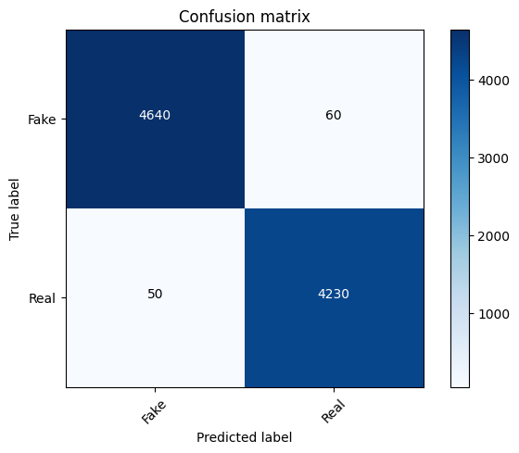

*Fig. 2. Confusion Matrix for Decision Tree Model*

Furthermore, we compared the performance of the Decision Tree model with that of SVM and LSTM. While SVM exhibited competitive performance, LSTM showed lower accuracy and F1-score, indicating the superiority of traditional machine learning approaches for this task.

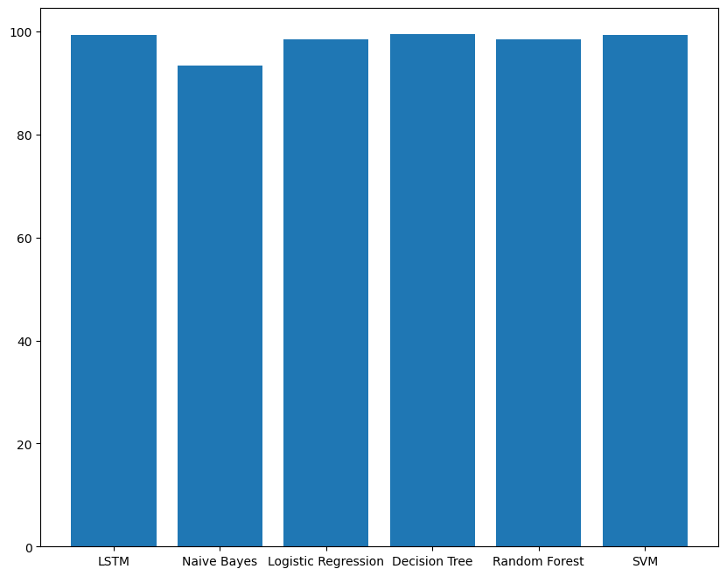

*Fig. 3. Bar Graph of Model Performance Metrics*

These findings underscore the importance of selecting appropriate machine learning algorithms tailored to the specific task of misinformation detection. The Decision Tree model, with its ability to discern intricate patterns in data, emerges as a promising candidate for real-world applications in combating fake news and promoting information integrity.

## *AUC and ROC Curve Analysis*

We generated AUC and ROC curves for the Decision Tree model to visualize its discriminative performance.

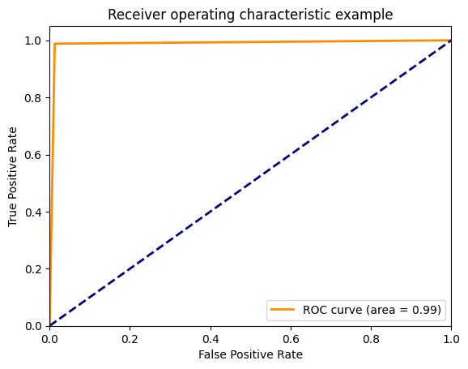

*Fig. 4. ROC Curve for Decision Tree Model*

As depicted in Fig. 4., the Decision Tree model indicating its robust discrimination capability without feature scaling.

|  |  |  |  |
| --- | --- | --- | --- |
| Proposed Objective | Classifier applied | Accuracy (%) | Precision (%) |
| FakeNewsAI: Identifying and Flagging misinformation through ml model | Naïve Bayes  Logistic Regression  Decision Tree  Random Forest  SVM  LSTM | 93.32  98.47  99.53  98.44  99.29  97.29 | 94.01  98.53  98.33  98.55 |

# CONCLUSION & FUTURE SCOPE

In this research, we explored the application of various machine learning models for the detection and classification of misinformation, with a focus on addressing the pervasive spread of fake news in digital environments. Our investigation encompassed the evaluation of Naive Bayes, Logistic Regression, Decision Tree, Random Forest, Support Vector Machine (SVM), and Long Short-Term Memory (LSTM) models, assessing their performance across key metrics such as accuracy, precision, recall, and F1-score. Our findings revealed that the Decision Tree model emerged as the top performer, demonstrating superior accuracy and classification capabilities compared to other models. Leveraging its ability to capture intricate patterns in data, the Decision Tree model showcased robust discrimination capability in identifying instances of misinformation. While SVM exhibited competitive performance, LSTM lagged in terms of all metrics, suggesting the dominance of traditional machine learning approaches in this domain.

Moving forward, there are several promising avenues for advancing the field of misinformation detection using machine learning. Firstly, optimizing existing models like Decision Trees and SVMs could enhance their performance and generalization capabilities through hyperparameter tuning and feature engineering. Secondly, exploring advanced deep learning architectures such as CNNs and RNNs may improve the detection of nuanced misinformation, especially in multimedia content. Developing robust adversarial defense mechanisms is crucial to safeguarding models against manipulation. Additionally, extending research to real-time detection in dynamic online environments and enhancing interpretability and explainability of models are vital for fostering trust and transparency. By addressing these areas, future research can contribute to the development of more effective and reliable misinformation detection systems, ultimately promoting a more informed and resilient information ecosystem.

# REFERENCES

[1] Pennycook, G., & Rand, D. G. (2021). Fighting misinformation on social media using crowdsourced judgments of news source quality. Proceedings of the National Academy of Sciences, 118(3), e1920059118.

[2] Mittelstadt, B. D., Allo, P., Taddeo, M., Wachter, S., & Floridi, L. (2016). The ethics of algorithms: Mapping the debate. Big Data & Society, 3(2), 2053951716679679.

[3] Lazer, D. M., Baum, M. A., Benkler, Y., Berinsky, A. J., Greenhill, K. M., Menczer, F., ... & Zittrain, J. L. (2018). The science of fake news. Science, 359(6380), 1094-1096.

[4] Guess, A., Nagler, J., & Tucker, J. (2019). Less than you think: Prevalence and predictors of fake news dissemination on Facebook. Science Advances, 5(1), eaau4586.

[5] Allcott, H., & Gentzkow, M. (2017). Social media and fake news in the 2016 election. Journal of Economic Perspectives, 31(2), 211-36.

[6] Tufekci, Z. (2018). YouTube, the Great Radicalizer. The New York Times, 10.

[7] Khan, J. Y., Khondaker, M. T. I., Afroz, S., & Iqbal, A. (2020). Combating Fake News Using Machine Learning and Deep Learning Techniques. In Handbook of Research on Deceptive Online Behavior and Detection Methods (pp. 32-49). IGI Global.

[8] Manzoor, S. I., Singla, J., & Nikita. (2020). Combating Fake News using Machine Learning and Natural Language Processing. International Journal of Computer Applications, 179(2), 8-11.

[9] Singla, J. (2019). Fake News Detection Using Machine Learning Algorithms. International Journal of Computer Applications, 182(14), 7-11.

[10] Khatter, H. (2019). News Recommender System: A Case Study on Fake News Detection. International Journal of Advanced Research in Computer Science, 10(2), 44-49.

[11] Abdullah-All-Tanvir, Ehesas Mia Mahir, Saima Akhter” Detecting Fake News using Machine Learning and Deep Learning Algorithms”, 2019 7th International Conference on Smart Computing & Communications (ICSCC).